

Data Structures

Themba Shongwe (SHNTHE021)

**Data Structures**

In today’s world, many systems make use of Artificial intelligence. Artificial intelligence has a become a very huge resource to many companies due to the vast information it holds. This information stems from developers feeding A.I systems data and information collected over decades all around the world, to make one program that makes it easier for users to access information from anywhere in the world. As a Computer Scientist, it imperative that I understand how the data that is collected, is stored and retrieved by users. I also understand the need to provide factual information and also provide an option to update misinformation/outdated information. In this section, I was exploring two commonly used data structures and how well they handle real-world data supplied through text files.

## **AIM:**

The aim for this is assignment is to develop a Java program which allows manipulation (i.e. querying and updating) to a dataset provided by a user to the program. The program must be able to manage loading a text File containing a knowledge base derived from GenericsKB, a dataset of general knowledge statements. The program must be able to give users information that is deemed correct by the knowledge. The other aim for the assignment is to evaluate prior knowledge of arrays and binary search tree, to get the practically evaluate which is more effective when it comes to handling, searching, updating, and adding elements of the data.

## **METHOD:**

Apparatus used:

* Computer (supporting wsl)
* Files with data to use for test cases.

My thought process for the program was to make a program which will take in each line

and separate each data entry by line. This served convenient as I know every line has

the same data fields (term, statement, and confidence score) so it then made it easier

to think up ways to access the data that I would need to handle the different userrequests which would be to search, update and add new data to the knowledge.

# **OOP DESIGN(overview):**

**Classes created:**

* ***mainInterface.java:***

This is the main class which acts as the interface connecting the user to the knowledge base. It is the umbrella class which connects two major classes,

GenericsKbArrayApp.java and GenericsKbBSTApp.java, which process the user interaction differently depending on which data structure the user wanted to use, an array or binary search tree respectfully. The mainInterface prompts the user to choose which data structure they like to use, then will generate questions whilst knowing which class is being used.

* ***GenericsKbArrayApp.java****:*

This class is used to process the knowledge into an array data structure. I first loaded the knowledge base into the array by making each line into a GenericsKbArrayApp object which has a term, statement and confidence score.I then included getter methods to access the data easily. This then made the searching portion of the program easier as I would just return the required statement or confidence score if the term was found. For the Array App, I could not add an element, so in this program I provided an update feature for specified term(only updates if confidence score is higher).

* ***GenericsKbBSTApp.java:***

This part of the program uses the Binary Search Tree as its data structure. It incorporate the binary Search tree, binary tree, binary treenode , binary queue and binary queuenode classes provided by the university (University Of Cape Town).It also utilises the datastore class which will explain in the next bullet point.The tree contains nodes which all contain data (a single line in the knowledge base) and the reference to the next tree node. This make it easier to traverse and search for required term statements and confidence score.

* ***datastore.java:***

The datastore class is used for the creation of binary tree nodes(for the most part). The class creates objects depending on the amount of data provided, that contain a term, statement and confidence score with their respective getter methods.This then makes it easier to store a single line of data as it is easier to access an object.

# **TESTING:**

**ArrayApp:**

**prompting user to choose data structure**.

**Uploading knowledge base and searching in the array part of the program.**

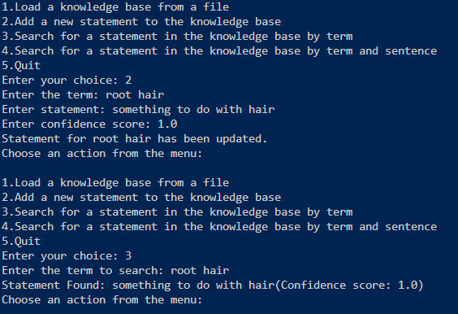

**updating statement in the array.(also applies for binary search tree)**

**Binary Search Tree:**

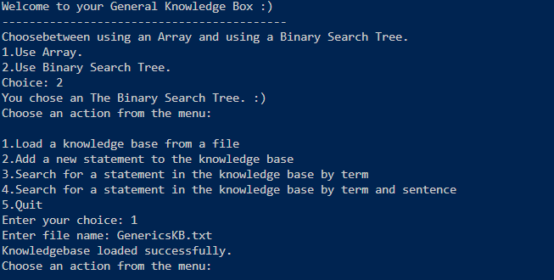 **prompting user to choose data structure followed by uploading knowledge base**.

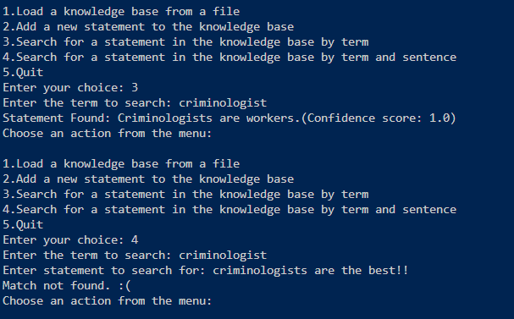

**Searching**

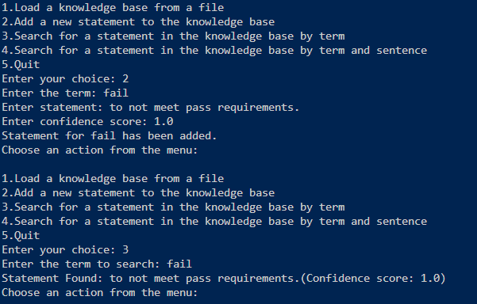

**adding to the tree and search if it really added.**

# **CREATIVITY:**

* For the creativity portion, I did not include much, all that I feel constitutes creativity would be me adding emoticons at the end of response statements. This is because I wanted to give a sense of relaxation to users to feel welcomed. Also including the “**welcome to the General knowledge box**” statement and prompting the user to choose preferred structure.
* Another thing that I believe shows creativity would be me doing a text terminal mainInterface to accommodate for me not having the time to actually make a GUI.

**Git Commit History(From latest to oldest):**

1. **Commit:** 64975b42c74d5ba466d6cfa0f19739a924f2d3bd  
   **Author:** Themba Shongwe  
   **Date:** Mon Mar 17 14:06:29 2025 +0000  
   **Message:** Addition of Makefile.
2. **Commit:** 18d6b26978646917ebf0078d372415be4c53d42b  
   **Author:** Themba Shongwe  
   **Date:** Mon Mar 17 08:58:51 2025 +0000  
   **Message:** Finished programs with mainInterface which will act as the interface between the user and the data structure programs.
3. **Commit:** dc67e1dfc1e023fc4dbc2bcf8d28f51ca9d65638  
   **Author:** Themba Shongwe  
   **Date:** Sun Mar 16 22:35:26 2025 +0000  
   **Message:** GenericsKbArrayApp and dataStore Java files commented and with their javadocs.
4. **Commit:** b97bad615edb0bdedd359f3b08e89e27f4b72861  
   **Author:** Themba Shongwe  
   **Date:** Sun Mar 16 22:10:17 2025 +0000  
   **Message:** Commented GenericsKbBSTApp along with its Javadoc.
5. **Commit:** 480f8ef47111edf303059b08d859ae7bf8b28052  
   **Author:** Themba Shongwe  
   **Date:** Sun Mar 16 20:07:05 2025 +0000  
   **Message:** GenericsKb apps, fully working. Have to add javadocs and comments.
6. **Commit:** 19dc719394bc245e129ab861a6be9c5ad14b7cdf  
   **Author:** Themba Shongwe  
   **Date:** Sun Mar 16 17:29:17 2025 +0000  
   **Message:** Updated and commented GenericsKbArrayApp, along with unfinished GenericsKbBSTApp, with its project files.
7. **Commit:** 744f2df0ee3fbc970300783eaf01e4f599357d07  
   **Author:** Themba Shongwe  
   **Date:** Sat Mar 15 18:54:34 2025 +0000  
   **Message:** First commit, GenericsKBArray.java is uncommented.
8. **Commit:** 7467a329f8fbd1237eeabf89472f6b5568f92982  
   **Author:** Themba Shongwe  
   **Date:** Fri Mar 14 21:46:01 2025 +0200  
   **Message:** First time adding to git, kinda nervous (INITIAL COMMIT ).

**CONCLUSION:**

Through this implementation, I was able to evaluate the strengths and weaknesses of both data structures. The array-based approach provided a simple yet inefficient way to store and update data, as searching and updating required linear traversal. On the other hand, the BST-based approach demonstrated better efficiency in searching and updating, thanks to its structured hierarchy. However, because the BST was unbalanced, performance could degrade in the worst case.

This project reinforced my understanding of data structures, file handling, and object-oriented programming in Java. Additionally, implementing a structured user interface improved the usability of the application. Future improvements could include balancing the BST, optimizing file I/O operations, and integrating more advanced search functionalities.

Overall, this assignment provided valuable hands-on experience in designing, implementing, and evaluating data structures in a real-world context.